Date of Visit:
Arrival Time: |  | Departure Time:
Group Name
Contact Name
Contact E-mail
Address
Postcode
Telephone number
Number of visitors
Ticket | Discounted rate (10% off admission prices) | No. |  | Cost
Leader | £0.00 | 1 | £ | 0.00
Adults | £9.00 |  | £
Children (aged 5 - 15) | £4.50 |  | £
Children (under 5) | £0.00 |  | £ | 0.00
Total |  |  | £
Guided tour booked? (guides to be contacted and paid separately - see website) for details)
Carol Overs

Leon Bracelin

Special Requirements?

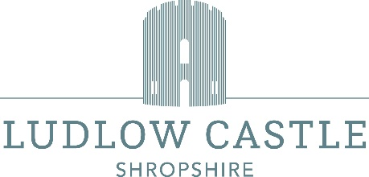
If you would like refreshments during your visit, please contact Chapter 66 café-restaurant to discuss your requirements 01584 878796.
Payment may be made in advance or on the day of your visit. We cannot offer refunds on advanced payments if numbers change.
Payment can be by cash or card. We do not accept American Express cards. We cannot accept cheques.
A VAT receipt will be provided. We do not produce invoices.
The group discount of 10% only applies for groups of 10 or more paying visitors when paid for in one transaction.
Please e-mail this form to info@ludlowcastle.com; you will be sent confirmation of your booking

