Date of Visit:
Arrival Time: |  | Departure Time:
Contact Name:
Contact e-mail:
School Name
Address

Postcode
Telephone number
Number of visitors
Ticket | Discounted rate | No. |  | Cost
Leader | £0.00 | 1 | £ | 0.00
Adults | £9.00 |  | £
Students (age up to 18) | £4.50 |  | £
Subtotal |  |  | £ |  | £
Souvenir packages (see separate document linked from website)
Package code | Cost each | No. required |  | Total
A | £2.00
B | £2.00
C1 | £3.50
C2 | £3.50
D | £5.00
E | £7.50
F | £10.00
Subtotal |  |  |  |  | £
Total due: |  |  |  |  | £
Guided tour booked? (guides to be contacted and paid separately - see website) for details)
Carol Overs
Leon Bracelin
Special Requirements?
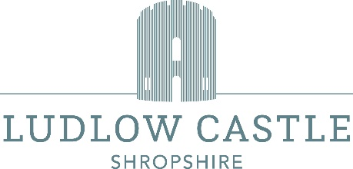
Payment may be made in advance or on the day of your visit. We cannot offer refunds on advanced payments if numbers change.
Payment can be by cash or card (we cannot accept cheques).
A VAT receipt will be provided. We do not produce invoices.
The group discount of 10% only applies for groups of 10 or more paying visitors when paid for in one transaction.
Please e-mail this form to info@ludlowcastle.com; you will be sent confirmation of your booking.

